Multiple-choice section – choose the correct answer

Question 1 [8.1]

An angle of 178° is:

A acute B reflex C obtuse D a right angle

Question 2 [8.1]

Co-interior angles on parallel lines:

A are complementary B are supplementary

C are equal D add to 360°

Question 3 [8.4]

The two triangles that make up the rectangle are congruent. Which test proves this?

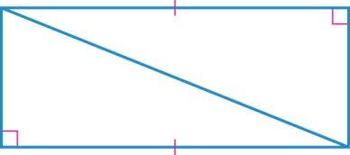

A SAS B ASA C SSS D RHS

Question 4 [8.2]

Find the value of the pronumeral *x*.

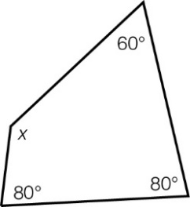

A 220° B 80° C 60° D 140°

Question 5 [8.3]

Which is *not* a transformation?

A reflection B translation C orientation D rotation

Question 6 [8.2]

Which triangle always has one pair of sides equal in length?

A scalene B isosceles C equilateral D right-angled

Question 7 [8.2]

The name given to a polygon with 10 sides is a:

A hexagon B decagon C octagon D dodecagon

Question 8 [8.2]

Which statement is true for a rhombus?

A diagonals bisect each other at right angles B all angles are right angles

C the shape has no side or diagonal properties D diagonals are parallel

Multiple-choice results: \_\_\_ /8

Short answer section

Question 9 2 marks [8.2, 8.3]

Choose the correct words from the list to fill each of the gaps in the following sentences.

*triangle square rectangle translation reflection rotation*

(a) The exterior angle of a \_\_\_\_\_\_\_\_\_\_\_\_\_\_\_ is equal to the sum of the two opposite interior angles.

(b) Another name for a flip is a \_\_\_\_\_\_\_\_\_\_\_\_\_\_\_\_.

Question 10 2 marks [8.1]

State if each of the following pairs of angles is complementary (add to 90°) or   
supplementary (add to 180°).

(a) 42° and 48° \_\_\_\_\_\_\_\_\_\_\_\_\_\_\_\_\_\_\_\_\_\_\_\_\_\_

(b) 15° and 165° \_\_\_\_\_\_\_\_\_\_\_\_\_\_\_\_\_\_\_\_\_\_\_\_\_

Question 11 4 marks [8.5]

The parallelogram below is made up of two congruent triangles, *ABC* and *CDA*.

Find the value of the angles *x, y* and *z*.

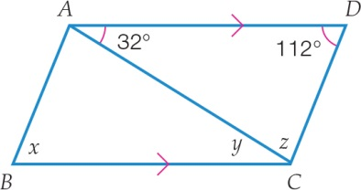

Question 12 4 marks [8.1]

Find the value of the pronumeral in each diagram by completing the steps given.   
Give reasons for your answer.

(a)

|  |  |
| --- | --- |
| C:\Users\ubuluay\Desktop\2nd ed\PM2e-8-ch-tests-exams-RWs\_SUPPLIED_V1_CORREX_230916\PM2e_08_EB_08_FBT_03.jpg | *x* + \_\_\_\_\_\_\_\_\_\_ = \_\_\_\_\_\_\_\_\_\_\_\_  *x* =  Reason: |

(b)

|  |  |
| --- | --- |
| C:\Users\ubuluay\Desktop\2nd ed\PM2e-8-ch-tests-exams-RWs\_SUPPLIED_V1_CORREX_230916\PM2e_08_EB_08_FBT_04.jpg | *x* + \_\_\_\_\_\_\_\_\_\_ + \_\_\_\_\_\_\_\_\_\_ = \_\_\_\_\_\_\_\_\_\_\_\_  *x* =  Reason: |

Question 13 2 marks [8.1]

Find the value of the angle *x* in the diagram. Give one of the following reasons:   
co-interior angles on parallel lines; corresponding angles on parallel lines; alternate angles on parallel lines.

|  |  |
| --- | --- |
| PM8_SmB_8_05tsa_RR | *x* =  Reason: |

Question 14 2 marks [8.1]

Find the value of the pronumeral in the diagram. Give one of the following reasons: adjacent angles or vertically opposite angles.

|  |  |
| --- | --- |
| C:\Users\ubuluay\Desktop\2nd ed\PM2e-8-ch-tests-exams-RWs\_SUPPLIED_V1_CORREX_230916\PM2e_08_EB_08_FBT_05.jpg | *a* =  Reason: |

Question 15 4 marks [8.2]

Find the value of the pronumerals, giving your reasons.

|  |  |
| --- | --- |
| (a)  **C:\Users\ubuluay\Desktop\2nd ed\PM2e-8-ch-tests-exams-RWs\_SUPPLIED_V1_CORREX_230916\PM2e_08_EB_08_FBT_06.jpg** | (b)  C:\Users\ubuluay\Desktop\2nd ed\PM2e-8-ch-tests-exams-RWs\_SUPPLIED_V1_CORREX_230916\PM2e_08_EB_08_FBT_07.jpg |

Question 16 3 marks [8.2]

(a) Divide the hexagon into triangles with no overlapping lines. How many triangles are there?

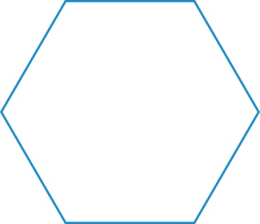

(b) If one triangle has an interior angle sum of 180°, what is the angle sum of a regular hexagon?

Question 17 6 marks [8.3]

(a) What does the translation [-4, -8] mean?

(b) Perform the translation of [-4, -8] on the shape *ABCD* and label the points of the transformed quadrilateral *A*′*B*′*C*′*D*′.

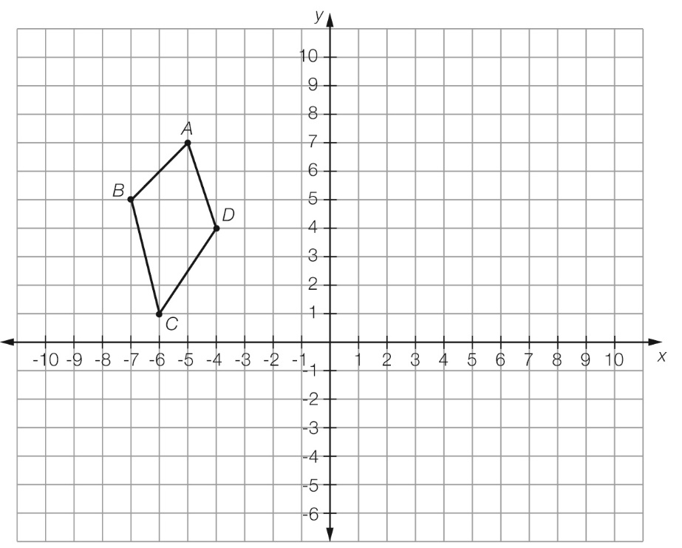

(c) What are the coordinates of the transformed quadrilateral?

*A*′ \_\_\_\_\_\_\_\_\_\_\_\_ *B*′ \_\_\_\_\_\_\_\_\_\_\_\_ *C*′ \_\_\_\_\_\_\_\_\_\_\_\_ *D*′ \_\_\_\_\_\_\_\_\_\_\_\_

Question 18 6 marks [8.3]

(a) Reflect the quadrilateral shown below in the *x*-axis and label the points of the transformed quadrilateral *A*′*B*′*C*′*D*′.

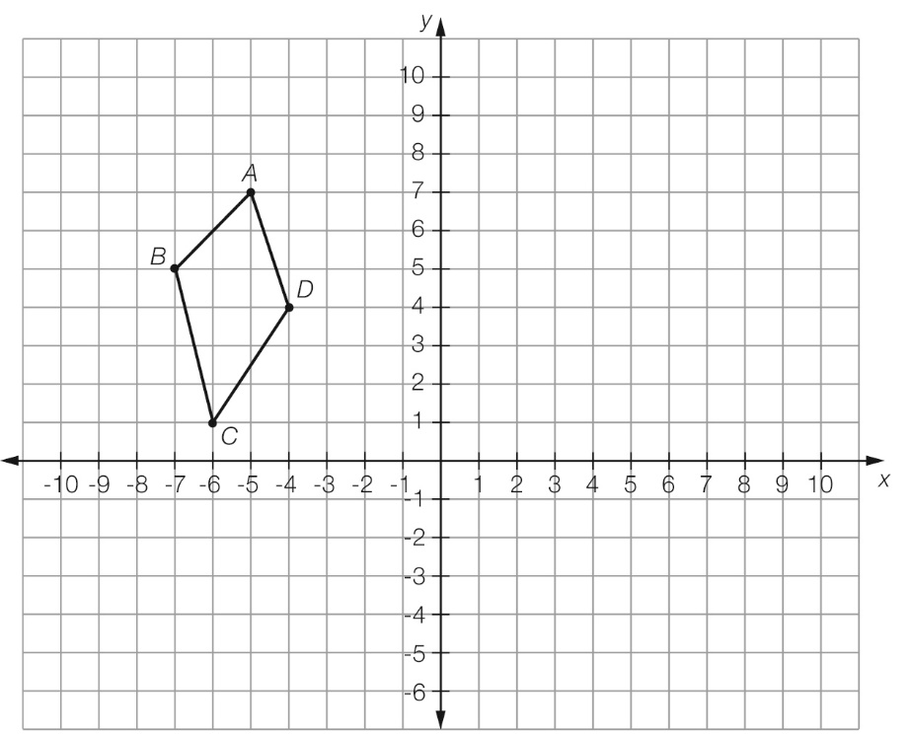

(b) What are the coordinates of the transformed quadrilateral?

*A*′ \_\_\_\_\_\_\_\_\_\_\_\_ *B*′\_\_\_\_\_\_\_\_\_\_\_\_ *C*′\_\_\_\_\_\_\_\_\_\_\_\_ *D*′ \_\_\_\_\_\_\_\_\_\_\_\_

Question 19 2 marks [8.5]

The figure below is a parallelogram. Name any two pairs of congruent triangles in it.

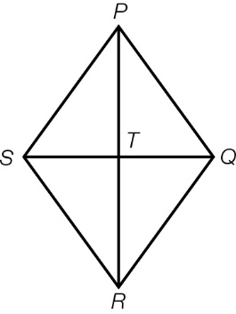

Question 20 2 marks [8.5]

The two quadrilaterals are congruent. Use your knowledge of matching angles and side lengths to find the value of the pronumerals.

|  |  |
| --- | --- |
| PM8_SmB_8_12tsa_RR | *x* = \_\_\_\_\_\_\_\_\_\_\_\_\_\_\_ m  *y* = \_\_\_\_\_\_\_\_\_\_\_\_\_\_\_\_° |

Question 21 2 marks [8.4]

Use congruent triangles and known angle facts to find the value of the pronumerals in the quadrilateral. Give reasons for your answer.

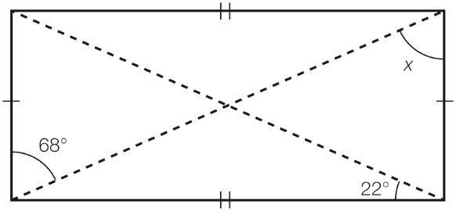

Short answer results: \_\_\_ / 41

Extended answer section

Question 22 4 marks [8.2]

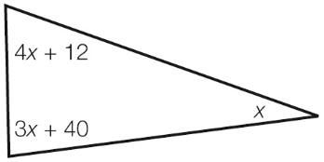

(a) Find the value of *x*.

(b) Find the size of each angle.

Extended answer results: \_\_\_ / 4

TOTAL test results: \_\_\_ / 53